The project is a means to access and view information from the animal shelter database. The project creates a way to view the information in a datatable that has the ability to filter through some preset filters. Those filters being Water Rescue, Mountain or Wilderness Rescue, Disaster or Individual Tracking, and Reset. The three filters give you a list of dogs that are popular in those fields, while the reset returns the data table to its original state.

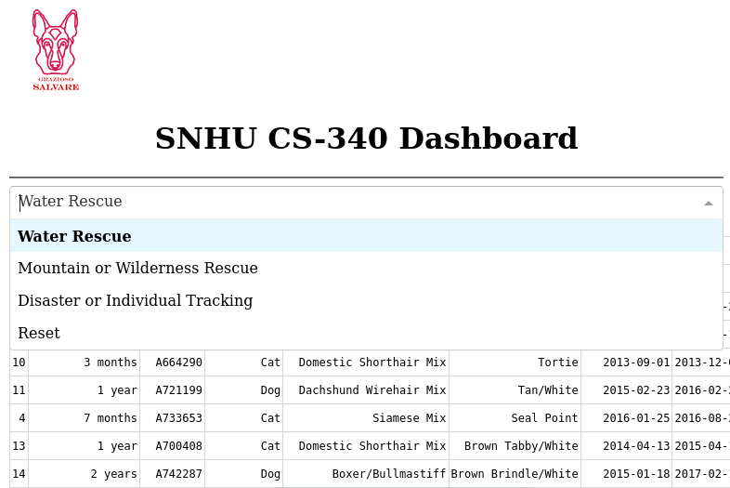

Along with the data table, there is a pie chart. The pie chart gives a visual representation of how many of each breed there are.

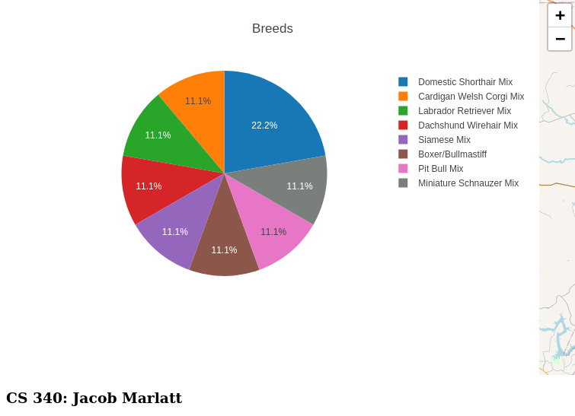

Lastly there is a geolocation chart that will show you the location of the selected animal.

The project was created using mongodb as the database source. Mongo was used because it was a simple means of finding and sorting out databases, along with its ability to be secure. It was also used because of its capabilities to work easily with Python. Having Python running the made code means that the entire process was simpler because of its simple design.

The project was created by using python and a CRUD method. Using CRUD means there are 4 main functions: create, read, update, delete. These functions were created as the structure the entire project would sit on top of. The visual side of the project was created with dash. Dash is a simple yet effective way to create visual representations of our data.

With every project there are some issues that come and go in the creation of the final project. There were multiple times where the code would result in blank results, meaning a run through of every aspect was needed to be done to find the cause. After looking back at not only the code being worked on, but previous code that was thought to be complete would result in finding the cause of the issue. From slight syntax errors to having a letter where it was not supposed to be, all these issue were located and solved.